Lab 5 – Mapping Avalanche Risk   
using Slope, Aspect, and Elevation

## Background

An avalanche is defined as a large mass of snow, ice, earth, rock or other material in swift motion down a mountainside or over a precipice (Webster, 2012). The possibility of an avalanche occurring is a risk that outdoor adventurers take every time they venture into the backwoods during the winter. Numerous avalanche risk centers operate extensive programs every winter to help analyze and predict avalanche hazard. These avalanche centers typically assess risk in terms of terrain variables combined with climate/weather conditions. Based on these factors, it is possible to create a map showing areas that fall under specific risk categories. This exercise involves creating an ArcGIS ModelBuilder model that takes risk categories as input factors and generates an output map highlighting areas based on an established risk coloring scheme.

## Problem Statement

Winter backwoods adventure include activities such as cross-country skiing, snowshoeing, and snowmobiling. It is a common pastime for many people in mountainous areas, including Utah, Idaho, and Wyoming. There are specific risks to these activities, such as hypothermia and getting caught in an avalanche. In the world, more than 150 people are killed per year by an avalanche (National Geographic). Backwoods enthusiasts need to be aware of the potential avalanche hazard for the area they are going to visit. They also need to know that avalanche hazard is continually changing due to weather and ground conditions.

Avalanche information centers such as the Northwest Weather and Avalanche Center and the Sawtooth National Forest Avalanche Center publish advisories throughout the avalanche season to help warn people about avalanche prone areas. The American Avalanche Association describes avalanche hazards and provides safety information for North America. They provide a “North American Danger Scale” which describes the likelihood of an avalanche occurring and the expected size of the avalanche. (see Figure 1)

Northwest Avalanche Center: <http://www.nwac.us/forecast/previous>

Sawtooth Avalanche Center: <http://www.jhavalanche.org/statetrailmaps/index.php>

American Avalanche Association: <http://www.avalanche.org/>

It should be relatively clear from these sample advisories that it is possible to identify the rough aspect, slope, and elevation associated with the various warning levels. Note that not every advisory includes every hazard level. Nor does each advisory give information for the complete range of terrain factors that influence avalanche potential. Most avalanche advisory sites give tabular data only. However, some sites are beginning to show maps of avalanche hazard areas such as Wyoming State Trails Website: <http://www.jhavalanche.org/statetrailmaps/index.php>

You will use ArcGIS Pro’s ModelBuilder to develop a model that is flexible enough to generate any hazard level for any combination of terrain parameters in any location. Your approach should include calculating slope and aspect for the input digital elevation model (DEM); then using a Raster Calculator to return only those cells that meet the specified requirements. You will then create a map from the output to show the locations that have avalanche hazard, the degree of the hazard (i.e. low to extreme), and the corresponding color as described by the American Avalanche Association. The North American Danger Scale is a description of the danger levels from low to extreme for the United States and Canada. It can be found on several avalanche awareness websites including the American Avalanche Association’s website.

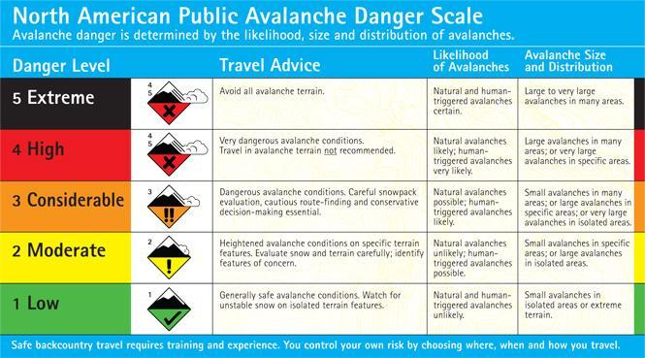

Figure 1: Table showing the different hazards and other stats on avalanches.

## Spatial Considerations

There are many factors that contribute to avalanches. However, it is generally accepted that terrain is the most significant factor. For the purposes of this project, you will assume that this set of terrain factors is reduced to a three-parameter set called the “three A’s of avalanches.” Altitude, slope, and aspect.

Altitude refers to the elevation above mean sea level. Generally higher altitudes tend to have a greater avalanche risk. Angle refers to the slope of the terrain. As one would expect, higher slopes tend to have a higher risk of an avalanche. This factor is also known as steepness. Aspect, or direction, refers to the compass direction the slope is facing. As noted above, shady slopes with north and northeastern aspects tend to have a greater risk of avalanche. The key terrain hazard factors for an avalanche are as follows:

Slope: The constrained distribution of slope in degrees (values must fall within the range 0 to 90 degrees). Slopes under 25 degrees and over 60 degrees typically have a low avalanche risk because of the angle of repose for snow. Snow does not accumulate significantly on steep slopes and does not easily flow on flat slopes. Distribution of avalanches by slope has a sharp peak between 35 to 45 degrees. That peak hazard lies at around 38 degrees. Unfortunately, slopes with the most dangerous steepness are favored for skiing. (Clark et al. 2002, p 11)

Aspect: The constrained distribution of Aspect is constrained circular distribution (values go from 0 to 360 and then back to 0 degrees). The three primary variables that influence snowpack evolution are temperature, precipitation, and wind. In medium latitudes of the Northern Hemisphere, more accidents occur on shady slopes with northern and north-eastern aspects. Slopes in the lee of the wind accumulate more snow, presenting locally deep areas and wind slabs. Cornices also accumulate on the downwind side of ridges and can contribute to avalanche danger. (Clark et al. 2002, p 11)

Profile: Convex slopes are statistically more dangerous than concave. The reasons lie partly in human behavior, and the tensile strength of snow layers versus the compression strength.

Surface: Full-depth avalanches are more common on slopes with smooth ground cover such as grass or a rock slab. Vegetation coverage is important for anchoring the snowpack; however, boulders or buried vegetation may create weak areas within the snowpack.

|  |  |  |  |
| --- | --- | --- | --- |
|  | **Altitude (meters)** | **Slope (degrees)** | **Aspect (degrees)** |
| **Low (1)** | 0 - 2200 | -1 - 25  60 - 90 | 180 - 225 |
| **Moderate (2)** | 2200 - 2400 | 25 - 30  55 - 60 | 135 - 180  225 - 270 |
| **Considerable (3)** | 2400 - 2600 | 30 - 32  50 - 55 | 90 - 135  270 - 315 |
| **High (4)** | 2600 - 2800 | 32 - 35  45 - 50 | 315 - 360  45 - 90 |
| **Extreme (5)** | 2800 - 10000 | 35 - 45 | -1 - 45 |

Table 1: The ratings on the left should be applied to the different altitudes, slopes, and aspects.

Table 1 is an example of avalanche risk hazard ranges for the altitude, slope, and aspect of the terrain. These values were obtained from an actual avalanche advisory posted on the Sawtooth National Forest Avalanche website.

## Data

Avalanche Risk Values: The numeric ranges of aspect, elevation, and slope associated with low, moderate, considerable, high, and extreme avalanche risk are generally posted on specific avalanche center websites and are updated daily throughout the avalanche season. The values shown in Table 1 were extracted from the Sawtooth National Forest Avalanche website and will be used for this laboratory exercise.

National Elevation Dataset: <http://gis.utah.gov/data/elevation-terrain-data/10-30-meter-elevation-models-usgs-ned/>

Download the elevation dataset for Utah provided by the USGS. You should either download the **10m** or **30m NED** for Salt Lake County using any of the methods on the page. The Snowbird Ski Resort is in Salt Lake county.

Utah Ski Area Boundaries: <http://gis.utah.gov/data/recreation/ski-areas/>

Download the boundaries (or locations) for this exercise Use the **Utah Ski Area Boundaries** link to take you to a FTP site, where you can find and download the shapefile.

## ModelBuilder Tools

You will use the following new tools in this exercise along with tools from previous labs:

Project: Changes the projection of the input feature class, layer, or raster to one you define

Slope: Identifies the slope of each cell within a raster and creates a new raster

Aspect: Identifies the aspect of the steepest slope in each cell within a raster and creates a new raster

Times: Takes input rasters and multiplies cell values where they overlap

## Example Model

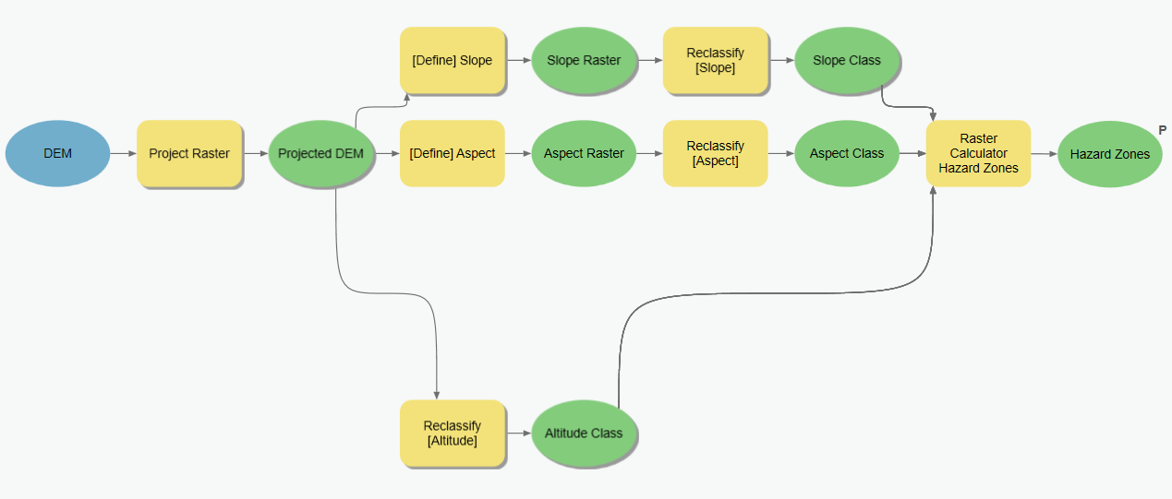

## Complete the Lab

For an advanced GIS student, the information up to this point is all you need to complete the assignment and create an output map from the results. Feel free to try conducting the analysis using only the information provided above. **If you complete the lab only using the information provided above (without using the step-by-step instructions below) make sure to indicate this in your lab report to be considered for extra credit.** If you need extra help, follow the step-by-step solution below.

## Step by Step Solution

You will notice in the example ModelBuilder model that there are groupings of functions. This is done to illustrate the separate considerations that were given in the instructions; specifically, altitude, slope, and aspect. The parameters are classified into ranges that correspond to the five avalanche hazards described. The last step is combining the three raster layers into one output raster indicating each of the individual avalanche hazards.

### Step 1

Use the Project Raster tool to transform the raster to the NAD 1983 projection. This will result in a new raster layer, assuming it is not already in that projection. This will ensure that all DEMs are projected into NAD 1983 for future projects as well.

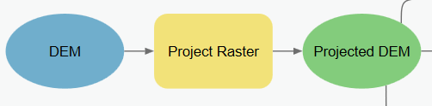

Figure 2: Using the Project Raster tool in ModelBuilder

### Step 2

Use the **Slope** tool to calculate the slope of the projected raster layer from Step 1.

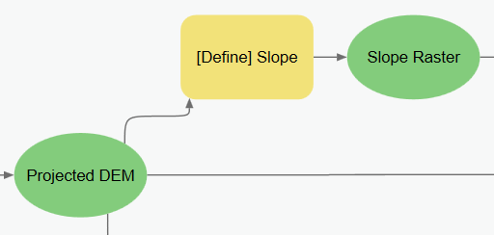

Figure 3 – Using the Slope tool in Model Builder.

### Step 3

Use the **Aspect** tool to calculate the aspect of the projected raster layer from step 1. Note the flat aspects are given the value of -1. Remember this when you use the reclassify tool.

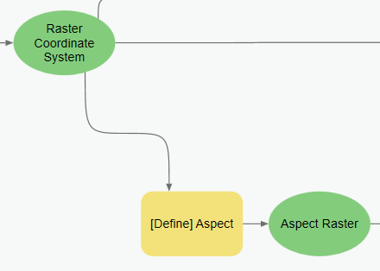

Figure 4 – Using the Aspect tool in Model Builder.

### Step 4

Use the **Reclassify** tool to reclassify the different values that are required for the parameters in Table 1. Note that different ranges can be reclassified to the same new value. An example of this is shown in Figure 6.

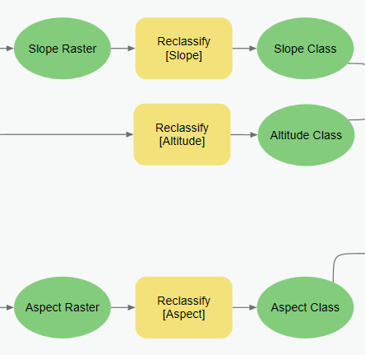

Figure 5 – Using the Reclassify tool on the Aspect, Slope, and Elevation rasters.

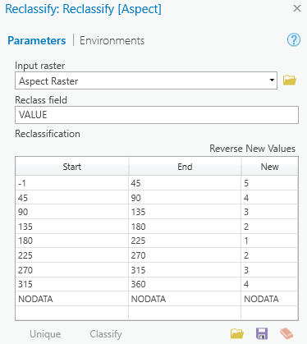

Figure 6 – The reclassify window for Aspect.

Add and edit the rows directly in the table. Enter the previous ranges given in Table 1 and then insert the values associated with their appropriate hazard level.

### Step 5

Use the **Raster Calculator** tool to combine the classification layers to create a map of the different hazard levels. Use the following expression or something similar in the raster calculator:

Con(("%Altitude Class%" == 1) & ("%Slope Class%" == 1) & ("%Aspect Class%" == 1), 1, Con(("%Altitude Class%" == 2) & ("%Slope Class%" == 2) & ("%Aspect Class%" == 2), 2, Con(("%Altitude Class%" == 3) & ("%Slope Class%" == 3) & ("%Aspect Class%" == 3), 3, Con(("%Altitude Class%" == 4) & ("%Slope Class%" == 4) & ("%Aspect Class%" == 4), 4, Con(("%Altitude Class%" == 5) & ("%Slope Class%" == 5) & ("%Aspect Class%" == 5), 5, 0)))))

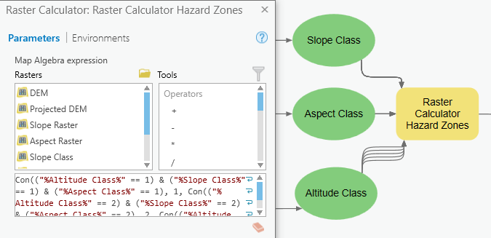

Figure 7: Raster Calculator Window in ModelBuilder.

Check the **Parameter** and **Add to Display** options on the Hazard Level raster layer.

## Deliverables

For the Snowbird Ski Resort near Alta, Utah, construct a ModelBuilder model that prepares all your input data for a terrain analysis, conducts the analysis, and creates a map showing the avalanche hazard levels. Use the colors shown in Table 2 to symbolize the raster cells. Use a grayscale or monochrome symbology (e.g. light blue to represent low hazards and darker blue to represent higher hazards). You may need to prepare the map coloring/symbology outside of Model Builder. Assign the legend with the appropriate labels from Table 2. Include the legend on your map labeling the levels from low to high, not with the numbers.

Write a brief report that presents your final model and clearly shows all elements of the model. Describe the steps and tools in your model and display your final map. Include any changes you made to the reclassifications or analysis and why you chose those methods. Make sure to review the rubric at the end of this chapter for the full requirements for the laboratory exercise.

## Extra Credits

Other options to reclassify the final avalanche hazard includes (1) multiplying the three terrain reclassified factors (altitude, slope, and aspect) together. This gives values from 1 to 125, which will again to be reclassified to values of 1 to 5 to be labeled with the hazard levels. The **Times** tool or **Raster Calculator** tool can be used here; (2) using the max classification value at each cell to determine highest risk; (3) adding (rather than multiply) the grids to set a scale from 0-15.

Get extra credit if you try a different method (multiply, add, max) to classify the final hazard level and give discussion of differences.

## References

American Avalanche Association website: (http://www.avalanche.org/, 2011).

Northwest Weather and Avalanche Center (http://www.nwac.us/, 2011)

Sawtooth National Forest Avalanche Center:

(http://www.sawtoothavalanche.com/index.html,2011)

Wikipedia: (http://en.wikipedia.org/wiki/Avalanche, 2011)

Merriam-Webster Dictionary: (http://www.merriam-webster.com/dictionary/avalanche, 2012).

## Example Map

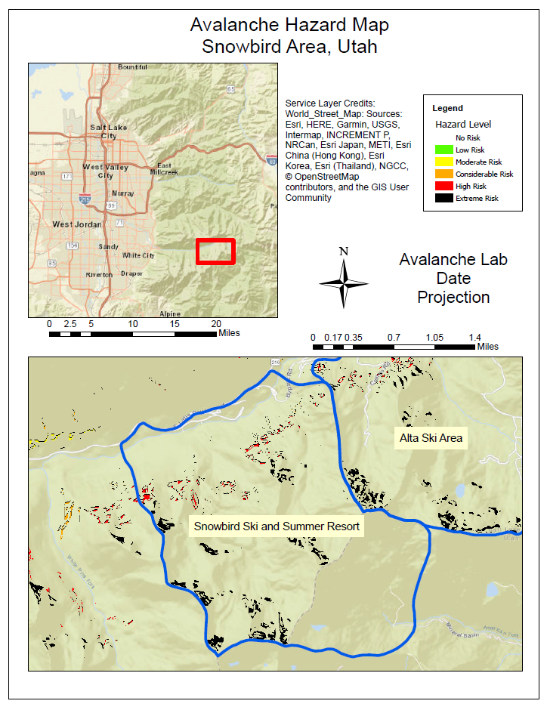

## Rubric for Mapping Avalanche Risk using Slope, Aspect, Elevation

|  |  |
| --- | --- |
| **Item** | **Points** |
| Assignment Title, Name, Date, Course | /5 |
| Summary of the requirements of the project | /5 |
| Describe your model   * List each of the tools used: (2 pts.) * List tool settings applied for the analysis (could someone repeat the assignment using your lab report?): (2 pts.) * List all input, intermediate, and output datasets: (2 pts.) * Describe each input dataset including type (point, line, polygon, raster) and the source of the data: (2 pts.) * Describe each output dataset (point, line, polygon, raster): (2 pts.) | /10 |
| * One full page (8.5 x 11) showing your model (5 pts.) * All text is readable (10pt. font minimum) (3 pts.) * All tools and data sets are shown (2 pts.) | /10 |
| * What areas of your study area have the greatest risk of avalanche? (2 pts.) * Would you change the reclassifications and how? (2 pts.) * Are your results as expected or did you find anything interesting or different than expected? (1 pt.) | /5 |
| Make a full page (8.5 x 11) map showing the results of your avalanche hazard study of the Snowbird Ski Resort area.   * Map Title: (1 pt.) * Neat Line: (1 pt.) * North Arrow: (1 pt.) * Scale Bar: (1 pt.) * Text box with author name, date, map projection: (1 pt.) * Avalanche risk map image: (5 pts.) * Each risk category clearly symbolized: (1 pt.) * Labeled roads or other reference data: (1 pt.) * Labeled points indicating location of ski resorts in the study area: (1 pt.) * Zoomed to an appropriate scale for viewing analysis results: (1 pt.) * All text is legible on printed map: (1 pt.) | /15 |
| **Bonus Task:** Repeat the lab exercise with a different dataset. Include in your report what data you used, how you acquired it, and what you may have changed to complete the exercise. Include an additional full-page map showing your results. | Instructor’s  Discretion |